**24**

**Electric Potential**

|  |
| --- |
| **CHAPTER OUTLINE** |

24.1 Electric Potential and Potential Difference

24.2 Potential Difference in a Uniform Electric Field

24.3 Electric Potential and Potential Energy Due to Point Charges

24.4 Obtaining the Value of the Electric Field from the Electric Potential

24.5 Electric Potential Due to Continuous Charge Distributions

24.6 Conductors in Electrostatic Equilibrium

* An asterisk indicates a question or problem new to this edition.

|  |
| --- |
| **SOLUTIONS TO THINK-PAIR-SHARE AND ACTIVITIES** |

**\*TP24.1 Conceptualize** Be sure you are clear on the two experiments that are performed and what can be measured. In the first experiment, the potential difference between the plates is adjusted until a drop is at rest. Then, the potential difference ∆*V*rest is measured. We assume we can measure *d*, the distance between the plates, and that we know *g* and the density **oil of the oil. We do not know *q* or *r*.

In the second experiment, the electric field is turned off and the oil drifts downward at constant speed. Because we can see a calibrated scale through the telescope and have access to a stopwatch, we can determine the terminal speed *vT* of the drop. We also assume we know the viscosity and density of air.

**Categorize** In both experiments, the oil drop is modeled as a *particle in equilibrium.*

**Analyze** (a) For the oil drop at rest, write out the equilibrium equation for forces in the vertical direction from the particle in equilibrium model:

 (1)

Substitute for the force components in Equation (1) using Equations 22.8, 24.6, and 5.5:



(b) For the oil drop moving downward at constant terminal speed, write out the equilibrium equation for force components in the vertical direction from the particle in equilibrium model:

 (3)

Substitute for the forces in Equation (3):



(c) Substitute Equation (4) for *r* into Equation (2) and solve for *q*:



 (5)

**Finalize** Equation (5) allows us to determine the charge on the oil drop by measuring the plate separation *d*, the voltage ∆*V*rest at which the drop is stationary, and the terminal speed *vT* of the drop when the electric field is turned off.

Often, the buoyant force is ignored because it is so much smaller than the other forces. We can see this in Equation (5) by realizing that the density of air (~1 kg/m3) is much smaller than that of oil (~800 kg/m3). If we ignore **air compared to **oil in Equation (5), the equation simplifies to



*Answer:* (c) 

**\*TP24.2** **Conceptualize** Be sure that you understand clearly the relationship between electric potential and electric field as discussed in Section 24.4. Because the graph of potential vs. position consists of a series of straight lines, we expect the electric field in each region to be constant in magnitude.

**Categorize** This problem will use the relationship between electric potential and electric field as discussed in Section 24.4.

**Analyze** Use Equation 24.16 to evaluate the electric field in each of the five distinct regions in the graph:



Finally, using these values, make a graph of the *x* component of the electric field as a function of position:

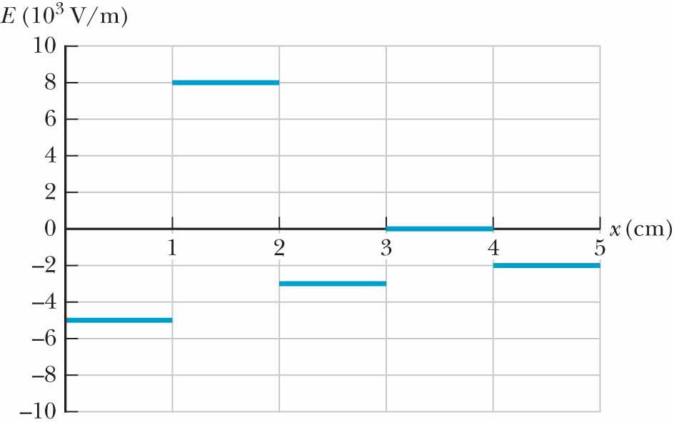

**Finalize** The electric field graph comes out to be relatively simple because the lines in the potential graph were all straight. One could imagine setting up this system with a series of parallel plates held at different voltages.

*Answer:*



**\*TP24.3** **Conceptualize** Be sure you are clear on the two experiments that are performed and what can be measured. In the first experiment, the oil drifts downward at constant speed. Because we can see a calibrated scale through the telescope and have access to a stopwatch, we can determine the terminal speed *vT* of the drop. We also assume we know the viscosity and density of air.

In the second experiment, a potential difference is applied between the plates and adjusted until the same drop is at rest. Then, the potential difference ∆*V*rest is measured. We assume we can measure *d*, the distance between the plates, and that we know *g* and the density **oil of the oil. We do not know *q* or *r*.

**Categorize** In both experiments, the oil drop is modeled as a *particle in equilibrium.* In the first experiment, the oil drop is moving at a constant downward velocity, so we can model it is a *particle under constant speed*.

**Analyze** (a) From the particle under constant speed model, we can find the terminal speed of each oil drop. We can use the equations provided in the problem to find the radius of each drop and the charge on it. These values appear in the expanded table below.

|  |  |  |  |  |  |
| --- | --- | --- | --- | --- | --- |
| **Drop #** | **∆*t* to fall 1.00 mm (s)** | **∆*V*rest (V)** | ***vT***  **(10–5 m/s)** | ***r***  **(**m)** | ***q***  **(10–19 C)** |
| 1 | 40.0 | 8.95 | 2.50 | 0.502 | 4.79 |
| 2 | 31.8 | 9.44 | 3.14 | 0.563 | 6.40 |
| 3 | 22.7 | 12.55 | 4.41 | 0.667 | 7.98 |
| 4 | 40.3 | 26.65 | 2.48 | 0.500 | 1.59 |
| 5 | 64.1 | 13.32 | 1.56 | 0.397 | 1.59 |
| 6 | 38.3 | 14.25 | 2.61 | 0.513 | 3.21 |
| 7 | 31.6 | 7.65 | 3.16 | 0.565 | 7.97 |
| 8 | 49.2 | 19.62 | 2.03 | 0.453 | 1.60 |
| 9 | 112 | 5.70 | 0.893 | 0.300 | 1.60 |
| 10 | 27.3 | 23.7 | 3.66 | 0.608 | 3.21 |

Looking at the last column of values, we see that there are repeating values of the some of the charges. There are only five different values, allowing for some small uncertainty in the measurements, so let’s make a histogram of the results for the charges on the oil drops:

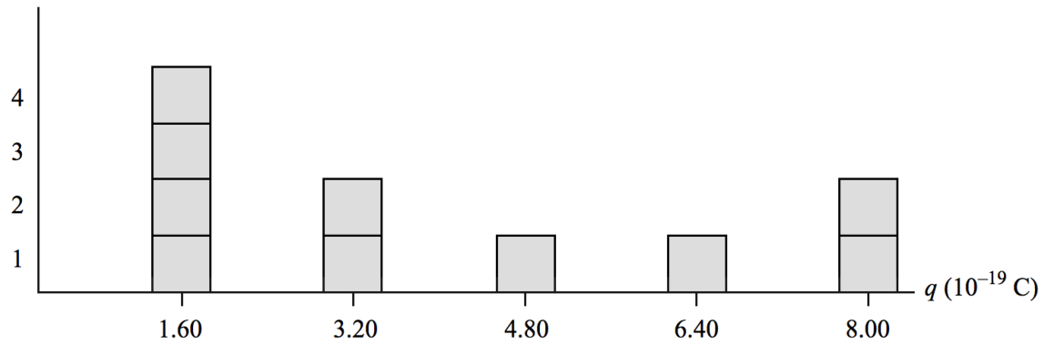

We notice the following:

(1) The higher four values are integer multiples of the lowest value.

(2) There are no values of charges other than these integer multiples.

The histogram suggests that the charges on the oil drops are quantized. It’s possible that the lowest value represents two fundamental charges and the next ones four, six, eight, and ten, but that’s unlikely. Why would there always be an even number of elementary charges? It could also be 3, 6, 9, 12, and 15 charges. That’s even more unlikely. The most likely interpretation is that the lowest value represents one elementary arge, and higher ones represent two, three, four, and five elementary charges. Therefore, we conclude that



(b) From the expanded table, we see that indeed all ten drops are between 0.1 and 1 **m in radius, so the manufacturer’s claim is confirmed for these ten drops.

**Finalize** Millikan’s experiment involved painstaking observations over several years. He received the 1923 Nobel Prize in Physics for his work, which was one of the earliest experiments to show the quantized nature of matter.

*Answer:* (a) 1.60 × 10–19 C (b) yes

|  |
| --- |
| **SOLUTIONS TO END-OF-CHAPTER PROBLEMS** |

Section 24.1 Electric Potential and Potential Difference

**P24.1** The potential difference is



and the total charge to be moved is



Now, from  we obtain



**P24.2** (a) The electron-electric field is an isolated system:



The potential difference is then



(b) From (a), we see that the stopping potential is proportional to the kinetic energy of the particle.



(c) The proton-electric field is an isolated system:



The potential difference is



Therefore, from (a),



**Section 24.2 Potential Difference in a Uniform Electric Field**

**P24.3** (a) From Equation 24.6,



(b) The force on an electron is given by



(c) Because the electron is repelled by the negative plate, the force used to move the electron must be applied in the direction of the electron's displacement. The work done to move the electron is



**P24.4** Assume the opposite. Then at some point *A* on some equipotential surface the electric field has a nonzero component Ep in the plane of the surface. Let a test charge start from point *A* and move some distance on the surface in the direction of the field component. Then  is nonzero. The electric potential charges across the surface and it is not an equipotential surface. The contradiction shows that our assumption is false, that Ep = 0, and that the field is perpendicular to the equipotential surface.

**P24.5** Arbitrarily take *V* = 0 at the initial point. Then at distance *d* downfield, where *L* is the rod length, *V* = –*Ed* and .

(a) The rod-field system is isolated:



Solving for the speed gives



(b)  Each bit of the rod feels a force of the same size as before.

**P24.6** (a) The system consisting of the mass-spring-electric field is 

(b) The system has both electric potential energy and elastic potential energy: Ue and Usp.

(c) Taking the electric potential to be zero at the initial configuration, after the block has stretched the spring a distance *x*, the final electric potential is (from equation 24.3)



By energy conservation within the system,



(d) 

(e) 

(f) The particle is no longer in equilibrium; therefore, the force equation becomes



Defining  we have .

Substitute  into the force equation:



(g) The result of part (f) is the equation for simple harmonic motion  with



(h) 

**Section 24.3 Electric Potential and Potential Energy Due to Point Charges**

**P24.7** By symmetry, a line from the center to each vertex forms a 30° angle with each side of the triangle. The figure shows the relationship between the length *d* of a side of the equilateral triangle and the distance *r* from a vertex to the center:

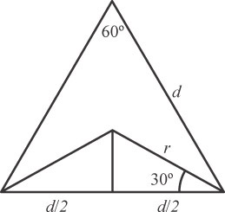

**ANS. FIG. P24.7**



The electric potential at the center is



**P24.8** (a) From Equation 24.12, the electric potential due to the two charges is



(b) The potential energy of the pair of charges is



The negative sign means that to separate the charges by an infinite distance (that is, to bring them to a state of zero potential energy).



**\*P24.9 Conceptualize** Figure 24.24 shows the physical setup for this attempt to reduce the outside electric field.

**Categorize** This problem can be argued from our understanding of Gauss’s law and the relationship between the potential and the electric field of a sphere.

**Analyze** As discussed in part (A) of Example 23.6, the electric field of a charged sphere is the same as that of a point particle of the same charge located at the center of the sphere. If the electric *field* is the same as a point charge, then the electric *potential* will also be the same as that of a point charge, as given by Equation 24.11:

 (1)

For points outside the shell, where *r* > *R*, the potential due to the shell will also be the same as that of a point particle at the center:

 (2)

Therefore, the total potential outside the shell is that due to both sources:

 (3)

In order for the electric field outside the shell to be zero, the derivative of the potential must be zero (Eq. 24.16):



Therefore, from Equation (2), the electric potential of the shell where *r* = *R*, is



**Finalize** This solution employs an understanding of Gauss’s law. Compare this problem to Problem 23.30, where an insulating shell was placed around your experimental apparatus.

*Answer:* 

**\*P24.10 Conceptualize** Study Figure P24.10 carefully and make sure you understand the structure of the NaCl primitive cell.

**Categorize** The problem involves a single evaluation of the energy of a system in its final configuration, so no analysis models are needed.

**Analyze** (a) According to the discussion above Equation 24.14, the total electric potential energy is that associated with every pair of charges in the structure. Let’s count the pairs:

Nearest-neighbor Na+–Cl–: 12 pairs

Body diagonal Na+–Cl–: 4 pairs

Face diagonal Na+–Na+: 6 pairs

Face diagonal Cl–– Cl–: 6 pairs

Now, let’s evaluate the total energy for each type of pair.

Nearest-neighbor Na+–Cl–:

 (1)

Body diagonal Na+–Cl–:

 (2)

Face diagonal Na+–Na+:

 (3)

Face diagonal Cl–– Cl–:

 (4)

Adding all the pairs gives



(b)The energy of the system is *negative*. Therefore, it is energetically favorable—that is, the energy of the system is reduced—when the crystal forms from the free ions.

**Finalize** In a macroscopic crystal with many primitive cells, calculations of energies become complicated because there are next-nearest neighbors, next-next-nearest neighbors, etc. Of course, the magnitudes of the energies of these interactions decrease because these higher-generation neighbors are farther apart than those in the primitive cell.

*Answer:* (a)  (b) See solution.

**P24.11** (a) Each charge is a distance  from the center.



(b) The potential at infinity is zero. The work done by an external agent is



**P24.12** (a) 



(b) 



(c) 



**P24.13** The work required equals the sum of the potential energies for all pairs of charges. No energy is involved in placing *q*4 at a given position in empty space. When *q*3 is brought from far away and placed close to *q*4, the system potential energy can

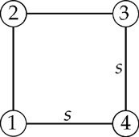

**ANS. FIG. P24.13**

be expressed as *q*3*V*4, where *V*4 is the potential at the position of *q*3 established by charge *q*4. When *q*2 is brought into the system, it interacts with two other charges, so we have two additional terms *q*2*V*3 and *q*2*V*4 in the total potential energy. Finally, when we bring the fourth charge *q*1 into the system, it interacts with three other charges, giving us three more energy terms. Thus, the complete expression for the energy is:





We can visualize the term  as arising directly from the 4 side pairs and 2 face diagonal pairs.

**P24.14** (a) The potential due to the two charges along the *x* axis is





ANS. FIG. P24.14 (a) shows the plot of this function for |*x*/*a*| < 3.

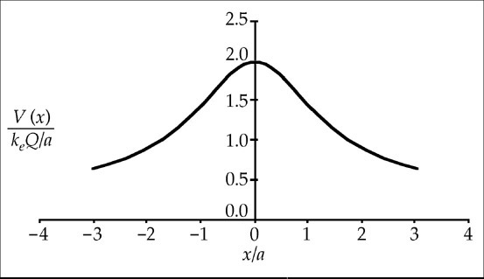

**ANS. FIG. P24.14 (a)**

(b) The potential due to the two charges along the *y* axis is





ANS. FIG. P24.14(b) shows the plot of this function for |*y*/*a*| < 4.

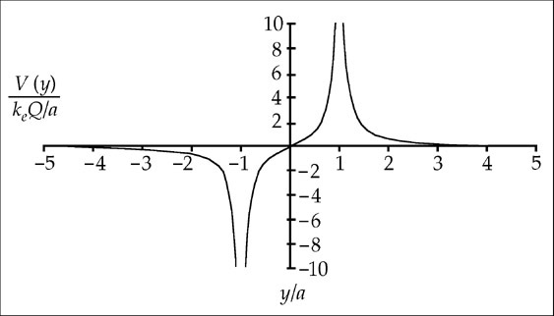

**ANS. FIG. P24.14 (b)**

**P24.15** (a) Each charge separately creates positive potential everywhere. The total potential produced by the three charges together is then the sum of three positive terms. There is , located at a finite distance from the charges, at which this total potential is zero.

(b) 

**P24.16** The original electrical potential energy is



In the final configuration we have mechanical equilibrium. The spring and electrostatic forces on each charge are



Then 

In the final configuration the total potential energy is



The missing energy must have become internal energy, as the system is isolated:



The increase in internal energy of the system is then



**P24.17** Consider the two spheres as a system.

(a) Conservation of momentum:

 or 

By conservation of energy,



and  which yields



suppressing units,



(b) If the spheres are metal, electrons will move around on them with negligible energy loss to place the centers of excess charge on the insides of the spheres. Then just before they touch, the effective distance between charges will be less than r1 + r2 and the spheres will really be moving .

**P24.18** Consider the two spheres as a system.

(a) Conservation of momentum:



or 

By conservation of energy,



and 



(b) If the spheres are metal, electrons will move around on them with negligible energy loss to place the centers of excess charge on the insides of the spheres. Then just before they touch, the effective distance between charges will be less than r1 + r2 and the spheres will really be moving .

**P24.19** A cube has 12 edges and 6 faces. Consequently, there are 12 edge pairs separated by *s*, 2 × 6 = 12 face diagonal pairs separated by , and 4 interior diagonal pairs separated by .



**P24.20** Each charge moves off on its diagonal line. All charges have equal speeds.



Solving for the speed gives



**Section 24.4 Obtaining the Value of the Electric Field from the Electric Potential**

**P24.21** For a general expression for the potential on the *y*-axis, replace the *a* with *y*. The *y* component of the electric field is





**P24.22** 

The sign indicates the direction of the *x* component of the field.

*x* = 0 to 1 cm: 

*x* = 1 to 3 cm: 

*x* = 3 to 4 cm: 

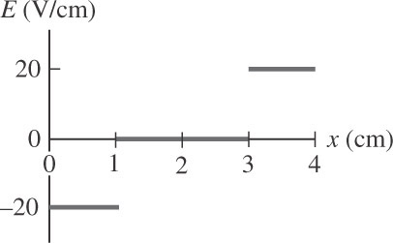

**ANS. FIG. P24.22**

**P24.23** (a) 

(b)  down

(c) ANS. FIG. P24.23 shows a sketch of the field lines.

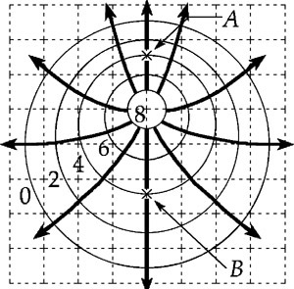

**ANS. FIG. P24.23**

**P24.24** 

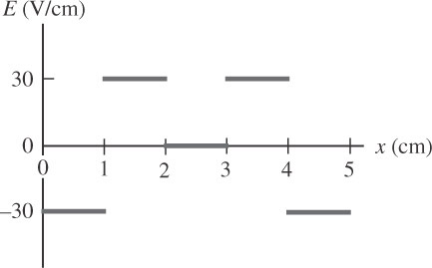

**ANS. FIG. P24.24**

The sign indicates the direction of the *x* component of the field.

*x* = 0 to 1 cm: 

*x* = 1 to 2 cm: 

*x* = 2 to 3 cm: 

*x* = 3 to 4 cm: 

*x* = 4 to 5 cm: 

**Section 24.5 Electric Potential Due to Continuous Charge Distributions**

**P24.25** (a) As a linear charge density,  has units of C/m. So  must have units of C/m2:

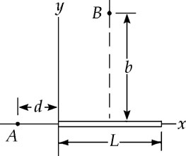

**ANS. FIG. P24.25**



(b) Consider a small segment of the rod at location *x* and of length *dx*. The amount of charge on it is  Its distance from *A* is *d* + *x*, so its contribution to the electric potential at *A* is



Relative to *V* = 0 infinitely far away, to find the potential at *A* we must integrate these contributions for the whole rod, from *x* = 0 to *x* = *L*. Then 

To perform the integral, make a change of variables to

*u* = *d* + *x*, *du* = *dx*, *u*(at *x* = 0) = *d*, and *u*(at *x* = *L*) = *d* + *L*:







**P24.26 **

Let  Then  and *dx* = –*dz.*

**





**P24.27 **



**\*P24.28 Conceptualize** We can divide the letter D into two distributions of charge: a semicircle and a straight rod. We have not investigated the potential due to a semicircle or at a point straight out from the center of a rod in the textbook. Are we in trouble?

**Categorize** The potential at a given point along the midline will be a superposition of those due to two continuous charge distributions.

**Analyze** First, the ring. In Example 24.5, we found the potential along the axis of a full ring. Because potential is a scalar, however, we do not need to worry about vectors, and we realize that the potential of a half ring is just half that of a full ring:

 (1)

where *x* is the distance along the midline from the center of the ring.

Now, what about the rod? In Example 24.7, we found the potential at a point along a line directed perpendicularly from the endpoint of a rod. Because potential is a scalar, however, we do not need to worry about vectors, and we realize that the rod in Figure P24.28 is just two rods, one directed to the left of the midline and the other to the right. Therefore, the potential due to the rod is just twice that found in Example 24.7:

 (2)

where *R* is the length of the “half rod” in Example 24.7.

The total potential at a position *x* along the midline is the sum of Equations (1) and (2):



**Finalize** Notice how quickly we can solve this problem. We did not need to do any new calculations, other than multiplying or dividing by 2. We just needed to recognize that the distributions in Figure P24.28 could be represented in terms of the geometries we had already studied in Examples 24.5 and 24.7.

*Answer:* 

**Section 24.6 Conductors in Electrostatic Equilibrium**

**P24.29**  A conductor of any shape forms an equipotential surface. If the conductor is a sphere of radius *R*, and if it holds charge *Q*, the electric field at its surface is *E* = *keQ/R2* and the –potential of the surface is   
*V* = *keQ/R*; thus, if we know *E* and *R*, we can find *V*. However, if the surface varies in shape, there is no clear way to relate electric field at a point on the surface to the potential of the surface.

**P24.30** Let’s calculate the electric field just outside the surface:



This should be the value of the electric field at the peak of the curve in Figure P24.30. We see, however, that the peak in the figure occurs at about 6.5 kN/C. Therefore, it is not possible that this figure represents the electric field for the given situation.

P24.31The surface area is *A* =4*πa*2. The field is then



It is not equal to  At a point just outside, the uniformly charged surface looks just like a uniform flat sheet of charge. The distance to the field point is negligible compared to the radius of curvature of the surface.

P24.32An approximate sketch is given at the right. Note that the electric field lines should be perpendicular to the conductor both inside and outside.

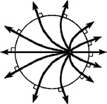

**ans. Fig. P24.32**

**P24.33** The fields are equal. The equation  suggested in the chapter for the field outside the aluminum looks different from the equation  for the field around glass. But its charge will spread out to cover both sides of the aluminum plate, so the density is . The glass carries charge only on area *A*, with . The two fields are  the same in magnitude, and both are perpendicular to the plates, vertically upward if *Q* is positive.

**P24.34** (a) 

(b) 



(c) 

(d) 



**P24.35** For points on the surface and outside, the sphere of charge behaves like a charged particle at its center, both for creating field and potential.

(a) Inside a conductor when charges are not moving, the electric field is zero and the potential is uniform, the same as on the surface, and .



(b) 



(c) 



**P24.36** (a) Inside surface: consider a cylindrical gaussian surface of arbitrary length  within the metal. Since *E* inside the conducting shell is zero, the total charge inside the gaussian surface must be zero:



so .

(b) Outside surface: consider a cylindrical gaussian surface of arbitrary length  outside the metal. The total charge within the gaussian surface is



(c) Gauss’s law:





**Additional Problems**

**P24.37** From Equation 24.13, solve for the separation distance of the electron and proton:



The separation distance *r*12 between the electron and proton is the same as the radius *r* of the orbit of the electron. Substitute numerical values:



Set this equal to *r* = *n*2(0.052 9 nm) and solve for *n*:



Which gives *n* = 1.42. Because *n* is not an integer, this is not possible. Therefore, the energy given cannot be possible for an allowed state of the atom.

**P24.38** (a) To make a spark 5 mm long in dry air between flat metal plates requires potential difference



(b) The area of your skin is perhaps 1.5 m2, so model your body as a sphere with this surface area. Its radius is given by , *r* = 0.35 m. We require that you are at the potential found in part (a), with . Then,





**P24.39** (a) The exact potential is



(b) The approximate expression –2*keqa*/*x*2 gives

–2*keqa*/(3*a*)2 = –*keq*/4.5*a*

Compare the exact to the approximate solution:

 .



**P24.40** From Example 24.6, the potential along the *x* axis of a ring of charge of radius *R* is



Therefore, the potential at the center of the ring is



When we place the point charge *Q* at the center of the ring, the electric potential energy of the charge–ring system is



Now, apply Equation 8.2 to the isolated system of the point charge and the ring with initial configuration being that with the point charge at the center of the ring and the final configuration having the point charge infinitely far away and moving with its highest speed:



Solve for the maximum speed:



Substitute numerical values:



Therefore, even if the charge were to accelerate to infinity, it would only achieve a maximum speed of 30.0 m/s, so it cannot strike the wall of your laboratory at 40.0 m/s.

**P24.41** We obtain the electric potential at *P* by integrating:



**P24.42** (a)  and the field at distance  
*r* from a uniformly charged rod (where  
*r* > radius of charged rod) is

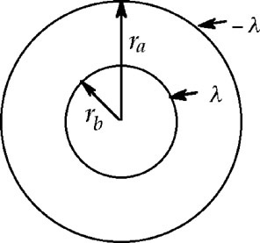

**ANS. FIG. P24.42**



In this case, the field between the central wire and the coaxial cylinder is directed perpendicular to the line of charge so that



or 

(b) From part (a), when the outer cylinder is considered to be at zero potential, the potential at a distance *r* from the axis is



The field at *r* is given by



But, from part (a), .

Therefore, .

**P24.43** (a) The positive plate by itself creates a field



away from the positive plate. The negative plate by itself creates the same size field and between the plates it is in the same direction. Together the plates create a uniform field  in the space between.

(b) Take *V* = 0 at the negative plate. The potential at the positive plate is then



The potential difference between the plates is



(c) The positive proton starts from rest and accelerates from higher to lower potential. Taking *Vi* = 488 V and V*f* = 0, by energy conservation, we find the proton’s final kinetic energy.







(d) From the kinetic energy of part (c),



(e) Using the constant-acceleration equation, ,



(f) The net force on the proton is given by Newton’s second law:



(g) The magnitude of the electric field is



(h) 

**P24.44** (a) Inside the sphere, .

(b) Outside,





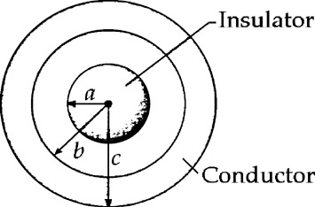

**ANS. FIG. P24.45**



P24.45 Choose as each gaussian surface a concentric sphere of radius *r*. The electric field will be perpendicular to its surface, and will be uniform in strength over its surface. The density of charge in the insulating sphere is



(a) The sphere of radius *r* < *a* encloses charge



(b) Applying Gauss’s law to this sphere reveals the magnitude of the field at its surface.



(c) For a sphere of radius *r* with *a* < *r* < *b*, the whole insulating sphere is enclosed, so the charge within is *Q*: .

(d) Gauss’s law for this sphere becomes:



(e) For   because there is no electric field inside a conductor.

(f) For  we know *E* = 0. Assume the inner surface of the hollow sphere holds charge *Q*inner. By Gauss’s law,



(g) The total charge on the hollow sphere is zero; therefore, charge on the outer surface is opposite to that on the inner surface:



(h) A surface of area *A* holding charge *Q* has surface charge *σ* = *q*/*A*. The solid, insulating sphere has small surface charge because its total charge *Q* is uniformly distributed throughout its volume. The inner surface of radius *b* has smaller surface area, and therefore larger surface charge, than the outer surface of radius *c*.

P24.46 (a) The field is zero within the metal of the shell. The exterior electric field lines end at equally spaced points on the outer surface because the surface of the conductor is an equipotential surface. The charge on the outer surface is distributed uniformly. Its amount is given by



Solving for the charge Q gives





(b) For the net charge of the shell to be zero, the shell must carry +55.7 nC on its inner surface, induced there by –55.7 nC in the cavity within the shell. The charge in the cavity could have any distribution and give any corresponding distribution to the charge on the inner surface of the shell. The charge on the interior surface is +55.7 nC. It can have any distribution. For example, a large positive charge might be within the cavity close to its topmost point, and a slightly larger negative charge near its easternmost point. The inner surface of the shell would then have plenty of negative charge near the top and even more positive charge centered on the eastern side.

(c) See the comments in (b). The charge within the shell is −55.7 nC. It can have any distribution. For example, the charge could be distributed on the surface of an insulator of arbitrary shape.

P24.47 We have



(a) Solving for the charge *Q* on the insulating sphere, we write, for the region *a* < *r* < *b*,



(b) We take *Q*′ to be the net charge on the hollow sphere. For *r* > *c*,



so



(c) For *b* < *r* < *c*, *E* = 0; therefore,  implies , where Q1 is the total charge on the inner surface of the hollow sphere. Thus, .

(d) Let Q2 be the total charge on the outer surface of the hollow sphere; then,



**Challenge Problems**

**P24.48** (a) The total potential is



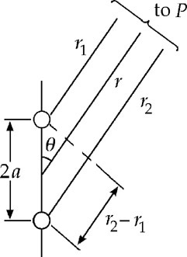

**ANS. FIG. P24.48**

From the figure, for *r* >> *a*,   
Note that *r*1 is approximately equal to *r*2. Then



(b) 

In spherical coordinates, the *θ* component of the gradient   
is . Therefore,



(c) For *r* >> *a*, *θ* = 90°: , 

For *r* >> *a*, *θ* = 0°: , 

 these results are reasonable.

(d)  because as *r* → 0, *E* → ∞. The magnitude of the electric field between the charges of the dipole is not infinite.

(e) Substituting  and  into  gives 

(f)  and 

**P24.49** For an element of area which is a ring of radius *r* and width *dr*, the incremental potential is given by , where



The electric potential is then given by



From a table of integrals,



The potential then becomes, after substituting and rearranging,



**P24.50** For the given charge distribution,



where 

and 

The surface on which *V*(*x*, *y*, *z*) = 0 is given by

 or 2r1 = r2

This gives:



which may be written in the form:

  **[1]**

The general equation for a sphere of radius *a* centered at (x0, y0, z0) is:



or  [2]

Comparing equations [1] and [2], it is seen that the equipotential surface for which *V* = 0 is indeed a sphere and that:



Thus, , , and 

The equipotential surface is therefore a sphere centered at , having a radius .

**P24. 51** (a) Take the origin at the point where we will find the potential. One ring, of width *dx*, has charge  and, according to Example 24.5, creates potential



The whole stack of rings creates potential



(b) A disk of thickness *dx* has charge  and charge-per-area *.* According to Example 24.6, it creates potential



Integrating,



|  |
| --- |
| **ANSWERS TO QUICK-QUIZZES** |

**1. (i)** (b) **(ii)** (a)

**2**. Ⓑ to Ⓒ, Ⓒ to Ⓓ, Ⓐ to Ⓑ, Ⓓ to Ⓔ

**3. (i)** (c) **(ii)** (a)

**4. (i)** (a) **(ii)** (a)

|  |
| --- |
| **ANSWERS TO EVEN-NUMBERED PROBLEMS** |

**P24. 2** (a) –2.31 kV; (b) Because a proton is more massive than an electron, a proton traveling at the same speed as an electron has more initial kinetic energy and requires a greater magnitude stopping potential; (c) 

**P24. 4** See P24.4 for full explanation.

**P24. 6** (a) isolated; (b) electric potential energy and elastic potential energy; (c) ; (d) Particle in equilibrium; (e) ; (f) ;   
(g) ; (h) The period does not depend on the electric field. The electric field just shifts the equilibrium point for the spring, just like a gravitational field does for an object hanging from a vertical spring.

**P24. 8** (a) 103 V; (b) 

**P24. 10** (a)  (b) See solution.

**P24. 12** (a) 5.43 kV; (b) 6.08 kV; (c) 658 V

**P24. 14** (a) ; (b) See ANS. FIG. P24.14 (b).

**P24. 16** 

**P24. 18** (a) 

and ; (b) faster than calculated in (a)

**P24. 20** 

**P24. 22** See ANS. FIG. P24.22.

**P24. 24** See ANS. FIG. P24.24.

**P24. 26** 

**P24. 28** 

**P24. 30** The electric field just outside the surface occurs at 16.0 kN/C. The peak in the figure occurs at about 6.5 kN/C. Therefore, it is not possible that this figure represents the electric field for the given situation.

**P24. 32** See ANS. FIG. P24.32.

**P24. 34 (**a) 0 (b) 7.99 × 107 N/C (outward)(c) 0 (d) 7.34 ×106 N/C (outward)

**P24. 36 (**a) -λ (b) +3 λ (c) 6*ke* λ/rradially outward

**P24. 38** (a) ~104 V; (b) ~10–6 C

**P24. 40** Even if the charge were to accelerate to infinity, it would only achieve a maximum speed of 30.0 m/s, so it cannot strike the wall of your laboratory at 40.0 m/s.

**P24. 42** (a) ; (b) 

**P24. 44** (a)  (b) 



**P24. 46** (a) The charge on the exterior surface is –55.7 nC distributed uniformly; (b) The charge on the interior surface is +55.7 nC. It can have any distribution; (c) The charge within the shell is –55.7 nC. It can have any distribution.

**P24. 48** (a)  (b) 

(c) Yes (d) No (e) 

(f) and 

**P24. 50** , $\frac{2}{3}R$